**Assignment No 03**

**Name: Muhammad Ahmed**

**Reg No: (FA20-BCS-036)**

**Submitted to: Mr. Muhammad Kamran**

**Dated: 2 June 2023**

**COMSATS UNIVERSITY ISLAMABAD ATTOCK CAMPUS**

**Create React Native Login & Signup Screen**

**App.js File Code:**

import * as React from 'react';

import { NavigationContainer } from '@react-navigation/native';

import { createNativeStackNavigator } from '@react-navigation/native-stack';

import Home from './src/Home';

import Signup from './src/Signup';

import Login from './src/Login';

const Stack = createNativeStackNavigator();

function App() {

  return (

    <NavigationContainer>

      <Stack.Navigator screenOptions={{ headerShown: false }}>

        <Stack.Screen name="Home" component={Home} />

        <Stack.Screen name="Signup" component={Signup} />

        <Stack.Screen name="Login" component={Login} />

      </Stack.Navigator>

    </NavigationContainer>

  );

}

export default App;

We can use 3 Screens in this Project and create src folder and add all the screens with images and design.

**Home.js:**

import React from 'react';

import {View, StyleSheet, Text} from 'react-native';

import Background from './Background';

import Btn from './Btn';

import { darkGreen, green } from './Constants';

const Home = (props) => {

  return (

    <Background>

      <View style={{ marginHorizontal: 40, marginVertical: 100 }}>

      <Text style={{ color: 'white', fontSize: 64 }}>Welcome</Text>

      <Text style={{ color: 'white', fontSize: 64, marginBottom: 40 }}>CUI Portal</Text>

      <Btn bgColor={green} textColor='white' btnLabel="Login" Press={() => props.navigation.navigate("Login")} />

      <Btn bgColor='white' textColor={darkGreen} btnLabel="Signup" Press={() => props.navigation.navigate("Signup")} />

      </View>

    </Background>

  );

}

const styles = StyleSheet.create({})

export default Home;

**Login.js:**

import React from 'react';

import {View, Text, Touchable, TouchableOpacity} from 'react-native';

import Background from './Background';

import Btn from './Btn';

import {darkGreen} from './Constants';

import Field from './Field';

const Login = (props) => {

  return (

    <Background>

      <View style={{alignItems: 'center', width: 460}}>

        <Text

          style={{

            color: 'white',

            fontSize: 64,

            fontWeight: 'bold',

            marginVertical: 20,

          }}>

          Login

        </Text>

        <View

          style={{

            backgroundColor: 'white',

            height: 700,

            width: 460,

            borderTopLeftRadius: 130,

            paddingTop: 100,

            alignItems: 'center',

          }}>

          <Text style={{fontSize: 40, color: darkGreen, fontWeight: 'bold'}}>

            Welcome Back

          </Text>

          <Text

            style={{

              color: 'grey',

              fontSize: 19,

              fontWeight: 'bold',

              marginBottom: 20,

            }}>

            Login to your account

          </Text>

          <Field

            placeholder="Email / Username"

            keyboardType={'email-address'}

          />

          <Field placeholder="Password" secureTextEntry={true} />

          <View

            style={{alignItems: 'flex-end', width: '78%', paddingRight: 16, marginBottom: 200}}>

            <Text style={{color: darkGreen, fontWeight: 'bold', fontSize: 16}}>

              Forgot Password ?

            </Text>

          </View>

          <Btn textColor='white' bgColor={darkGreen} btnLabel="Login" Press={() => alert("Logged In")} />

          <View style={{ display: 'flex', flexDirection :'row', justifyContent: "center" }}>

            <Text style={{ fontSize: 16, fontWeight:"bold" }}>Don't have an account ? </Text>

            <TouchableOpacity onPress={() => props.navigation.navigate("Signup")}>

            <Text style={{ color: darkGreen, fontWeight: 'bold', fontSize: 16 }}>Signup</Text>

            </TouchableOpacity>

          </View>

        </View>

      </View>

    </Background>

  );

};

export default Login;

**Signup.js:**

import React from 'react';

import {View, Text, Touchable, TouchableOpacity} from 'react-native';

import Background from './Background';

import Btn from './Btn';

import {darkGreen} from './Constants';

import Field from './Field';

const Signup = props => {

  return (

    <Background>

      <View style={{alignItems: 'center', width: 460}}>

        <Text

          style={{

            color: 'white',

            fontSize: 64,

            fontWeight: 'bold',

            marginTop: 20,

          }}>

          Register

        </Text>

        <Text

          style={{

            color: 'white',

            fontSize: 19,

            fontWeight: 'bold',

            marginBottom: 20,

          }}>

          Create a new account

        </Text>

        <View

          style={{

            backgroundColor: 'white',

            height: 700,

            width: 460,

            borderTopLeftRadius: 130,

            paddingTop: 50,

            alignItems: 'center',

          }}>

          <Field placeholder="First Name" />

          <Field placeholder="Last Name" />

          <Field

            placeholder="Email / Username"

            keyboardType={'email-address'}

          />

          <Field placeholder="Contact Number" keyboardType={'number'} />

          <Field placeholder="Password" secureTextEntry={true} />

          <Field placeholder="Confirm Password" secureTextEntry={true} />

          <View

            style={{

              display: 'flex',

              flexDirection: 'row',

              width: '78%',

              paddingRight: 16

            }}>

            <Text style={{color: 'grey', fontSize: 16}}>

             {' '}

            </Text>

            <Text style={{color: darkGreen, fontWeight: 'bold', fontSize: 16}}>

            </Text>

          </View>

          <View

            style={{

              display: 'flex',

              flexDirection: 'row',

              justifyContent :"center",

              width: '78%',

              paddingRight: 16,

              marginBottom: 10

            }}>

            <Text style={{color: 'grey', fontSize: 16}}>

               {" "}

            </Text>

            <Text style={{color: darkGreen, fontWeight: 'bold', fontSize: 16}}>

            </Text>

          </View>

          <Btn

            textColor="white"

            bgColor={darkGreen}

            btnLabel="Signup"

            Press={() => {

              alert('Accoutn created');

              props.navigation.navigate('Login');

            }}

          />

          <View

            style={{

              display: 'flex',

              flexDirection: 'row',

              justifyContent: 'center',

            }}>

            <Text style={{fontSize: 16, fontWeight: 'bold'}}>

              Already have an account ?{' '}

            </Text>

            <TouchableOpacity

              onPress={() => props.navigation.navigate('Login')}>

              <Text

                style={{color: darkGreen, fontWeight: 'bold', fontSize: 16}}>

                Login

              </Text>

            </TouchableOpacity>

          </View>

        </View>

      </View>

    </Background>

  );

};

export default Signup;

**Background Image Code:**

**Bacground.js:**

import React from 'react';

import {View, ImageBackground} from 'react-native';

const Background = ({ children }) => {

  return (

    <View>

      <ImageBackground source={require("./new.jpg")} style={{ height: '100%' }} />

      <View style={{ position: "absolute" }}>

        {children}

      </View>

    </View>

  );

}

export default Background;

**Btn.js:**

import {View, Text, TouchableOpacity} from 'react-native';

import React from 'react';

export default function Btn({bgColor, btnLabel, textColor, Press}) {

  return (

    <TouchableOpacity

    onPress={Press}

      style={{

        backgroundColor: bgColor,

        borderRadius: 100,

        alignItems: 'center',

        width: 350,

        paddingVertical: 5,

        marginVertical: 10

      }}>

      <Text style={{color: textColor, fontSize: 25, fontWeight: 'bold'}}>

        {btnLabel}

      </Text>

    </TouchableOpacity>

  );

}

**Field.js:**

import React from 'react';

import {TextInput} from 'react-native';

import {darkGreen} from './Constants';

const Field = props => {

  return (

    <TextInput

      {...props}

      style={{borderRadius: 100, color: darkGreen, paddingHorizontal: 10, width: '78%', backgroundColor: 'rgb(220,220, 220)', marginVertical: 10}}

      placeholderTextColor={darkGreen}></TextInput>

  );

};

export default Field;

**Background Image:**



**Code Write on SnackExpo:**

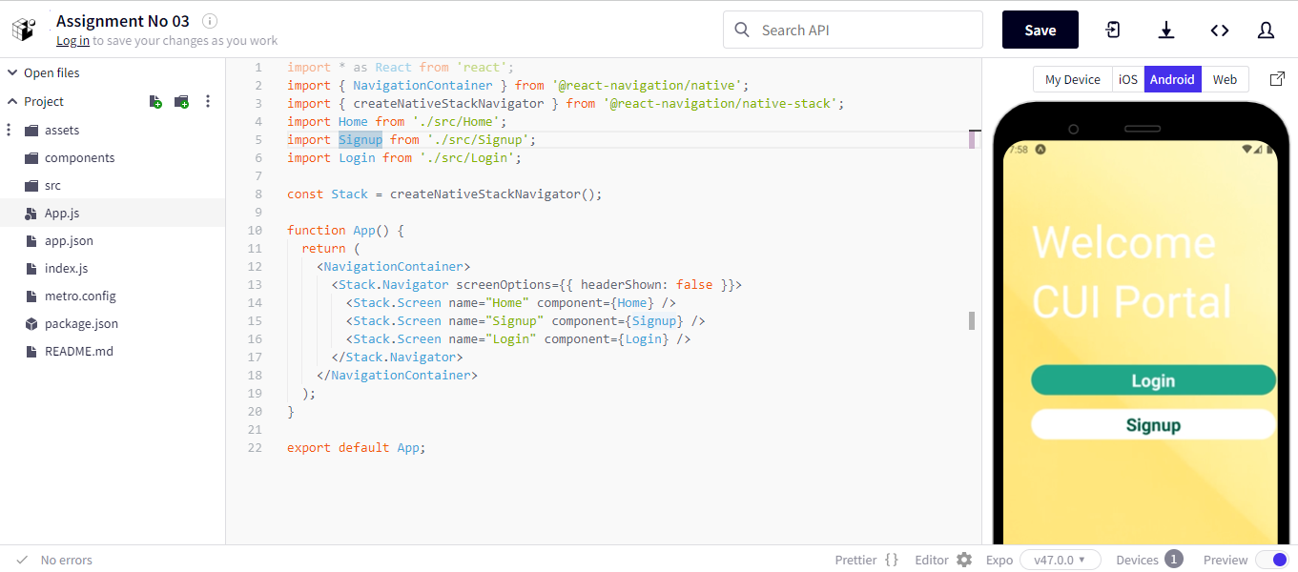

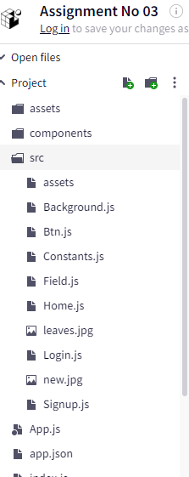

**Output Results:**

Welcome Page is here

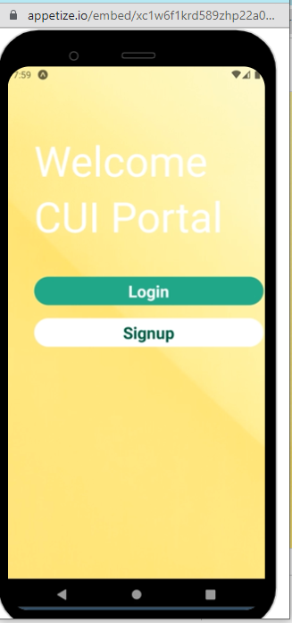

Then Click on Signup Button

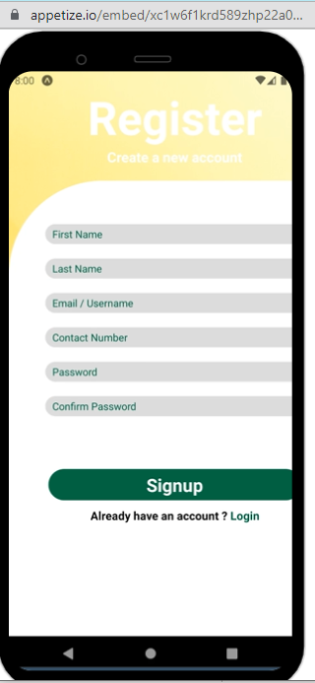

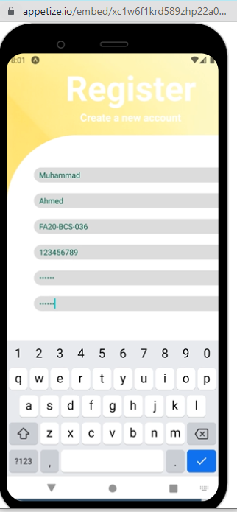

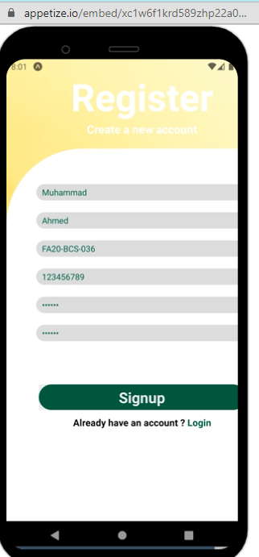

When you click Login button screen change

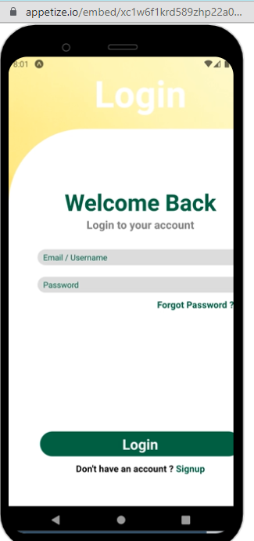

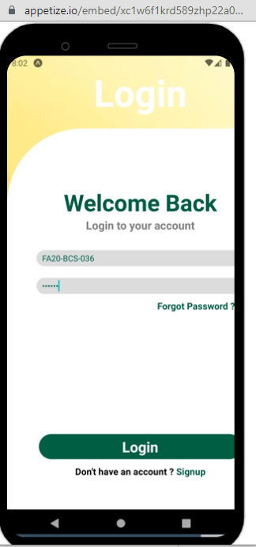

When you click on Login button it can generate an alert message



        
        
        